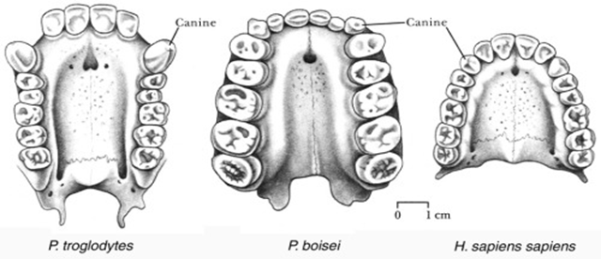

Enzyme video questions:
- Where does the substrate bind to the enzyme?
- Do sugars end in –ase or –ose?
- Do enzymes end in –ase or –ose?
- What are lactose intolerant people missing?
- Which is the substrate – lactose or lactase?
- Enzymes can also be called a c__________
- Lipase breaks down _______ (also known as _______)
- Salivary amylase breaks down _________
- Protease breaks down ___________
- In the wrong pH, enzymes become ____________. Explain how this stops them being able to work

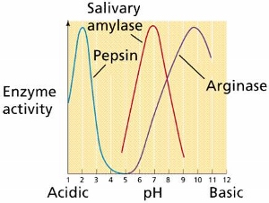
- Does salivary amylase continue to break down starch in the stomach?
- Explain how a longer time chewing would affect digestion
- Arginase is found in the intestine and pepsin is found in the stomach. Describe the different pH levels in the two intestines.
